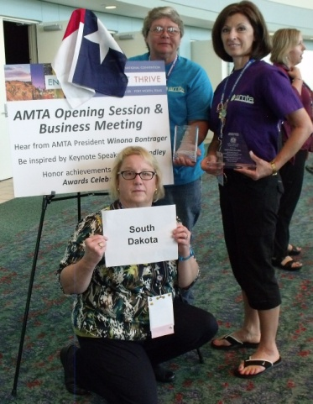``

**National Convention in**

**Fort Worth, TX attendees:**

Brenda Lanz,

Grace Lonning and Kris Skorseth (kneeling)

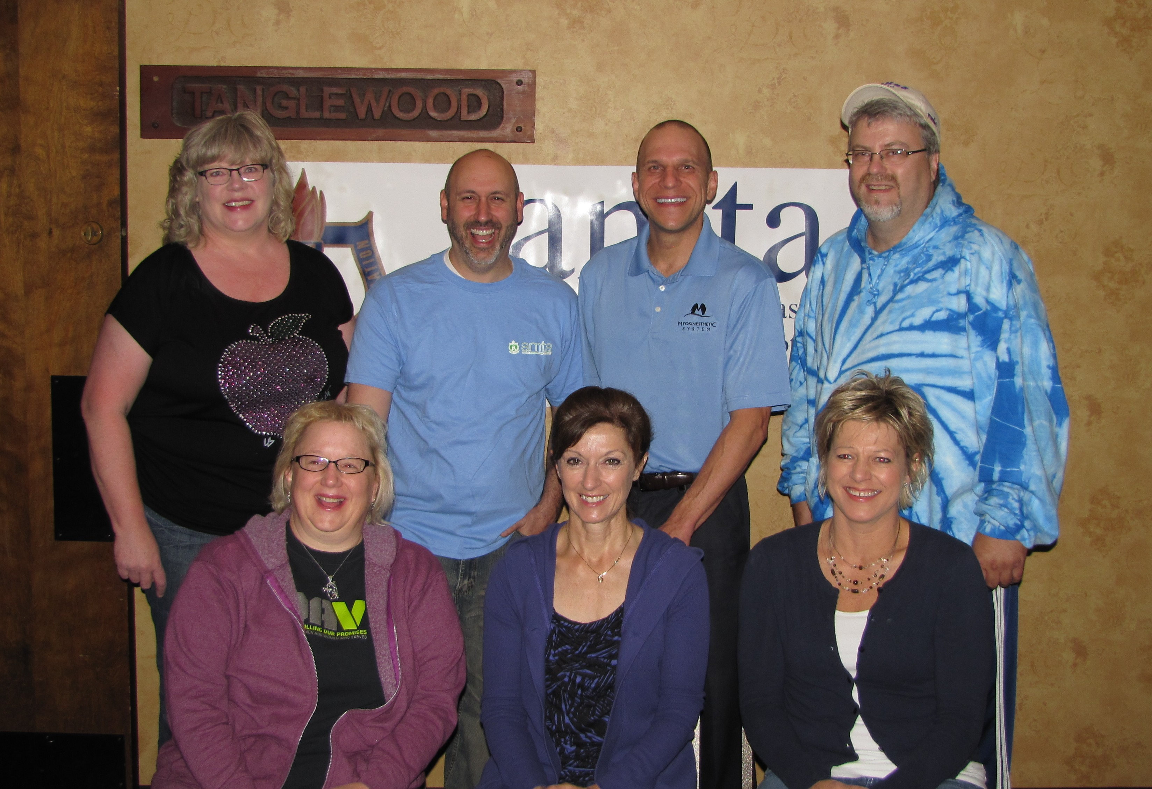

**Fall Convention (see article page 2):**

Back Row: Val Rowen; Teaching Assistant - Danny; Instructor – Mike Uriarte; Sheldon Haas; Front Row: Kris Skorseth; Grace Lonning; Sandy Berg

**HOWDY FROM TEXAS**

The National convention was held in Fort Worth, Texas September 25-28. Brenda Lanz, Grace Lonning, and myself (Kris Skorseth) attended this event. Brenda attended the President’s Council Meeting in Christine’s place and served as Sergeant at Arms for the House of Delegates. Grace checked out the presenters for our future Chapter conferences. I represented our Chapter at the House of Delegates meeting. The very inspiring keynote address was given by Doc Hendley, founder and president of Wine to Water. The awards ceremony followed and it was very exciting that our Chapter received 4 Hands out of 5 for the Give Chapters a Hand Award and we received the Government Relations Award in the small chapter category for our team efforts, professionalism, and commitment in preserving our licensing. Way to go members and a large thank you to Val for all her coordinating and communicating!

The educational sessions were great. Brenda and I were in Whitney Lowe’s class and he is an excellent presenter. We ran into some of our past presenters too and shared some laughs with them: James Waslaski, Eric Stephenson, Ralph Stephens, and Mary Ellen Derwis-Balaz. They all remember the good times and the camaraderie that they experienced in South Dakota.

The hot topic at the HOD and for the closing address on Saturday was the Affordable Care Act or Obamacare. Massage therapists have many questions as to what modalities will be included and how it affects massage therapists as well as how it will affect all of us as consumers and paying for or choosing plans. It boils down to: nobody really knows how this is all going to work, but National AMTA received the message that we want them to do their best to keep us all informed as they become aware of the facts. There were 3 position statements in the HOD to be voted on this year; please see my report in the Annual Chapter Meeting Packet. The HOD was truly interesting and I highly encourage any attendees at the National Conventions to sit in on the meeting, especially anyone that has been voted as a future delegate and all the alternates; it really is amazing. I regret never having done that as I think that my first year as a delegate would have been smoother as I would have known the “ins and outs”, so to speak.

The Texas Chapter held a BBQ at the Stockyards

and boy, it was a spread. Ask Grace how fast of a

draw she is. There was a mechanical bull and racing

armadillos.

National Convention 2014 will be in Denver and we encourage everyone to seriously consider attending.

--Kris Skorseth

### Inside This Issue

Howdy from Texas 1

SD-AMTA Officers and Chairpersons 2

Watertown 2

Results Are In! 3

SD-AMTA Anniversaries 3

New Members 3

The Winner Who Wasn’t! 3

AMTA National Elections 3

Calendar of Events 4

Coming Soon! 4

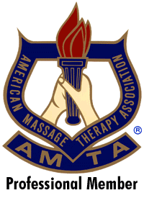

###### **The South Dakota American Massage Therapy Association Newsletter**

Autumn 2013

Volume 6, Issue 3

The Trained Touch

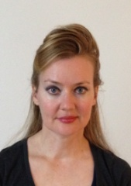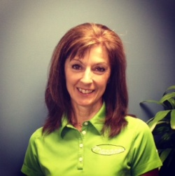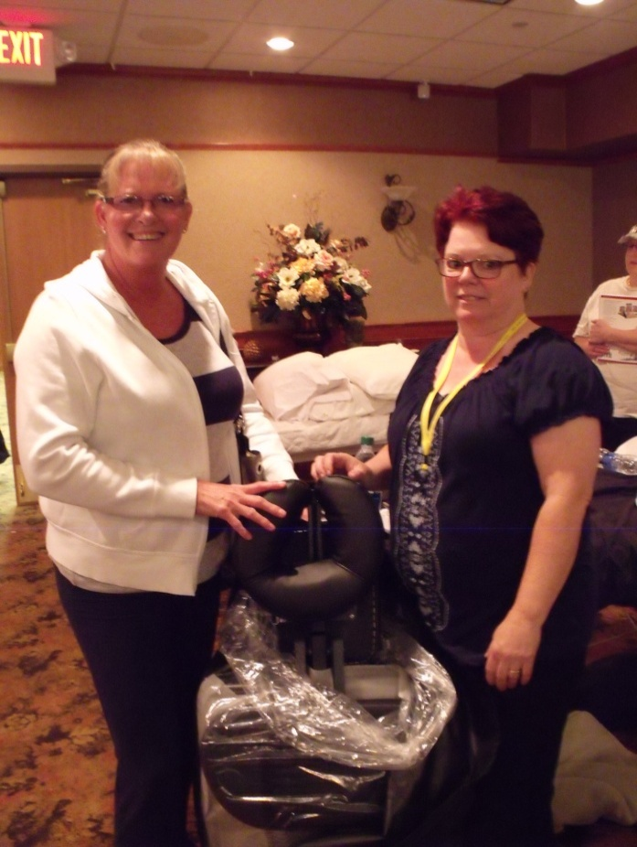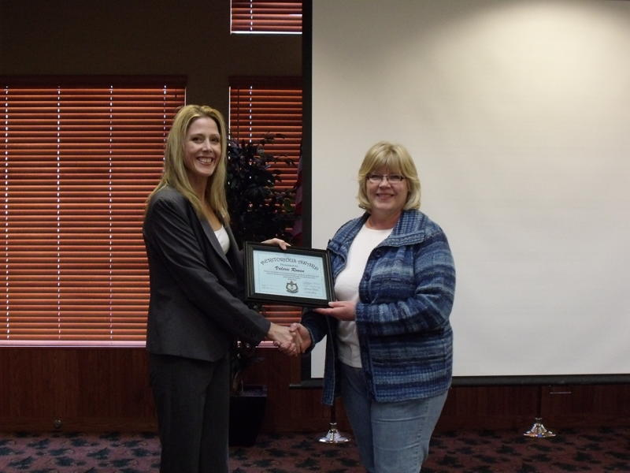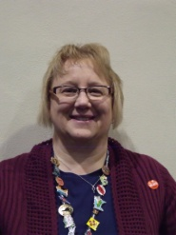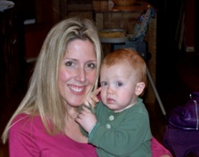

**FALL CONVENTION IN WATERTOWN**

Our Fall Convention was held in Watertown in September with Dr. Michael Uriarte presenting on the Myokinesthetic System (postural analysis and the nervous system’s process) and Ethics. There was a lot of laughter as Dr. Uriarte (your yard ee) believes that people retain more when they are having fun while learning. (That’s what I say.) While introducing himself and his work, he stated that, “this (technique) works on a very high percentage of people” and “that is the voodoo that I do”. Well, guess you had to be there, he was very animated and a delight to have visit our Chapter. The North Dakota Chapter had him present and highly recommended him, so thank you to North Dakota!

The Ethics portion was based on: “If you don’t take care of your body, where else are you going to live?” – unknown. He gave us super beneficial information about calories, exercise, and being a little “selfish” in order to be healthy. How many of us put the needs of others before our own? It is so true that if mama ain’t happy, ain’t nobody happy; or in this case, healthy. Dr. Uriarte shared this quote from Gandhi: “It is health that is real wealth and not pieces of gold and silver.”

Friday night after class, Sheila Grabow of Watertown opened up her home and yard to us for a BBQ. Everyone contributed something to the gathering and it was a very relaxing time in which all were able to swap massage stories, cases, and a few jokes as well as good ole’ laughter. I think that every one of us rolled away so full that we thought that we would never eat again. THANK YOU SHEILA FOR SHARING YOUR HOME WITH US!

--Kris Skorseth

**SD CHAIRS ROSTER 2013-2014**

**Historian Chair**Patricia Bleeker  
320 W 6th Ave  
Mitchell, SD 57301

[pjbleeker@amx.com](mailto:pjbleeker@amx.com)

**Education and Newsletter Chair**  
Grace Lonning (see 3rd VP)

**Membership/Recruitment/Public Relations Chair**Tara Hall  
38846 124th St  
Aberdeen, SD 57401  
605-225-7203 Home

605-228-1183 Cell  
[tarahall@nrctv.com](mailto:tarahall@nrctv.com)

**Nominations/Awards Chair**  
Sheldon Haas (see IPP)

**Website Chair**  
Karen Peschong (see 1st VP)

**Government Relations Chair**  
Valerie Rowen (see Treasurer)

**SD DELEGATE ROSTER 2013-2014**

**Delegate 2013-2014 HOD:**   
Kris Skorseth

(see secretary)

**1st  Alternate 2013 HOD**:   
Suzanne Braun

**2nd  Alternate 2013 HOD:**   
Patricia Bleeker  
320 W 6th Ave  
Mitchell, SD 57301

[pjbleeker@amx.com](mailto:pjbleeker@amx.com)

**1st  Alternate 2014 HOD**:   
Tara Hall  
38846 124th St  
Aberdeen, SD 57401  
605-225-7203 Home

605-228-1183 Cell  
[tarahall@nrctv.com](mailto:tarahall@nrctv.com)

**2nd  Alternate 2014 HOD:**   
Lauralee Hatch

6739 W Elmwood Dr  
Black Hawk, SD 57718

heavenlytouchrc@yahoo.com

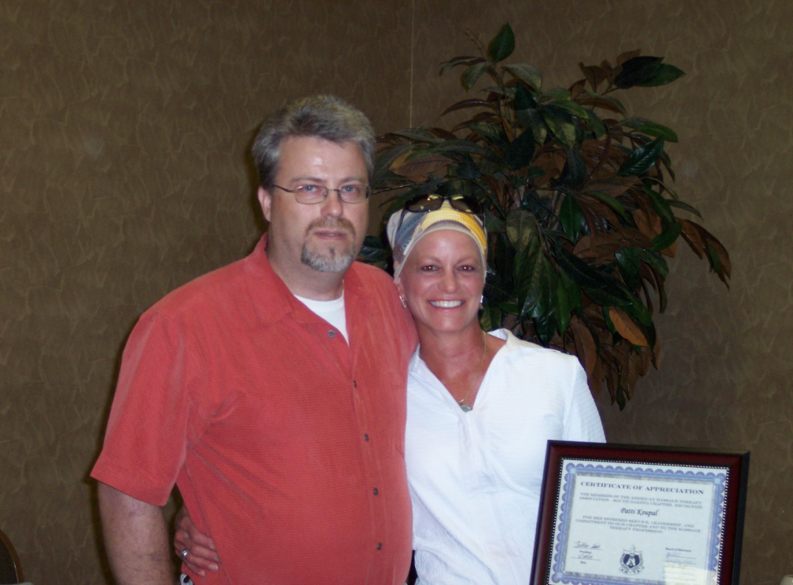

**SD OFFICERS 2013-2014**

**President**Christine Ellwein

722 West Pleasant Drive

Pierre, SD 57501  
605.222.9266

christinegors@hotmail.com

**Immediate Past President**

Sheldon Haas   
Midwest Massage Therapy

1904 S Wayland Ave

Sioux Falls, SD 57105

605.335.8558  
sheldonnlee@gmail.com

**1st Vice President**Karen Peschong

Attunement Specialists Therapeutic Massage & Bodywork

420 4th St NE, Suite 143

Watertown, SD 57201

605.878.1001

karen.mentele@gmail.com

**2nd Vice President**

Sandy Berg

116 England St

LaBolt, SD 57246

605.949.9401

healthykneads2@hotmail.com

**3rd Vice President**

Grace Lonning

405 8th Ave NW #207

Aberdeen, SD 57401  
605.725.4400

massagetherapy@nvc.net

**Treasurer**

Valerie Rowen

Touch of Wellness

327 S Fort StreetPierre, SD 57501-2415

605.295.1330 Cell

605.945.0013 Work

valerieandrickr@mncomm.com

**Secretary**

Kris Skorseth

Prairie Breeze Massage & Bodywork, LLC

307 6th Street, Suite #3

Brookings, SD 57006

605.692.5262

kristinegeezer@gmail.com

**SDAMTA Chapter**

**Board Members**

**SDAMTA Delegates & Chairs**



**Welcome New Members!**

**June**

Laura Alyea Rapid City

Lorraine Flynn Kyle

Laura Hardy Spearfish

Jessica Mann Sioux Falls

Elizabeth Stuard Box Elder

Morgan Pearson Canistota

**July**

No new members

**August**

Sarah Basche Jasper, MN

Sarah Bauer Rapid City

Kristin Younger Sioux Falls

**September**

Karisa Magee Fort Pierre

**October**

No report yet



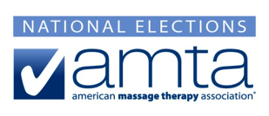

Be among the professional members that shape our association. Vote for our national leaders. Find out what their vision and goals are for the future of AMTA and the massage profession. Link up with candidates on the [AMTA official election website.](https://www.amtamassage.org/Volunteer-Connections/National-Opportunities/National-Elections.html) ***Your vote counts! Cast your vote by December 2nd.***

*Please contact Colleen Leeders at 877-905-2700 x150 or* [*ckleeders@amtamassage.org*](mailto:ckleeders@amtamassage.org) *if you have questions.*

**…And the Winner Wasn’t…**

We drew the name of a SDAMTA Member at the Fall Convention in Watertown to win $100, but that person had to be present to win. Melanie Geiger of Aberdeen was drawn, but since she was not there, **the drawing will increase to $200 next Fall**.

At the Spring Convention in Fort Pierre, we will draw the name of a SDAMTA member to win a Registration fee to the National Fall Convention in Denver. Must be present to win… so plan to attend! ($375 Value)

**Congratulations!**

2013 SD-AMTA Chapter Anniversaries

|  |  |
| --- | --- |
| **NAME** | **MEMBERSHIP**  **YEARS** |
| George Stroppel | 44 |
| R. Jean Schmidt | 39 |
| E. Marie Anderson | 36 |
| Brenda Lanz | 20 |
| Keith Norman | 20 |
| Grace Lonning | 20 |
| Patricia Weller | 20 |
| Rebecca Voss | 15 |
| Kathy Heller | 15 |
| Sheila Grabow | 10 |
| Shirley Hemel | 10 |
| Diane Schiefer | 10 |
| Bridget Bury | 10 |
| Barbara Gutierres | 10 |
| Maxine German | 10 |
| Carol Flack | 5 |
| Amber Yahnel | 5 |
| Karri Allen | 5 |
| Trisha Holm | 5 |
| Tanya Hymans | 5 |
| Rose McGuire | 5 |
| Jennifer Bullard | 5 |
| Sara Christians | 5 |
| Karen Peschong | 5 |
| Melissa Moore | 5 |
| Melanie Geiger | 5 |

**The Results Are In!**

A survey was given to SDAMTA members to evaluate our Chapter in specific areas. The results have been combined and are now available for your review. Log on to the Chapter website: www.amtasd.org

**Conventions**

**AMTA-SD Spring**

**Convention/Business Meeting**

April 25-26, 2014

AmericInn, Fort Pierre, SD

**AMTA 2014 National Convention**

September 17-20, 2014

Colorado Convention Center

700 14th Street

Denver, CO 80202

**AMTA-SD Fall Convention**

September 12-14, 2014

K Bar S Lodge

Keystone, SD

**Deadline for article submission for the next newsletter is February 12, 2014**



Daniel Carney, of Missoula, Montana will be the presenter at our Spring Convention in Fort Pierre, South Dakota. He will be teaching **CORE** Myofascial work. He has a tremendous amount of knowledge and experience to share with us. His work emphasis is with athletes, but of course can be used with most clients.

You can learn more about him by viewing his web-site:

**www.corebodywork.com**

# **Calendar of Events**



Grace Lonning, LMT

Newsletter Editor

405 – 8th Avenue NW #207

Aberdeen, SD 57401